

**Western Australian Certificate of Education**

**ATAR course examination, 2018**

**Question/Answer Booklet**

12 PHYSICS

Name

**Test 7 – Modern Physics**

|  |  |  |  |  |  |  |  |  |  |  |
| --- | --- | --- | --- | --- | --- | --- | --- | --- | --- | --- |
| Student Number: In figures |  |  |  |  |  |  |  |  |  |  |

**Mark: $\frac{}{\text{4}\text{9}}$**  In words

#### Time allowed for this paper

Reading time before commencing work: five minutes

Working time for paper: sixty minutes

**Materials required/recommended for this paper**

To be provided by the supervisor

This Question/Answer Booklet

Formulae and Data Booklet

***To be provided by the candidate***

Standard items: pens, (blue/black preferred), pencils (including coloured), sharpener, correction fluid/tape, eraser, ruler, highlighters

Special items: non-programmable calculators satisfying the conditions set by the School Curriculum and Standards Authority for this course

**Important note to candidates**

No other items may be taken into the examination room. It is your responsibility to ensure that you do not have any unauthorised notes or other items of a non-personal nature in the examination room. If you have any unauthorised material with you, hand it to the supervisor before reading any further.

**Structure of this paper**

|  |  |  |  |  |  |
| --- | --- | --- | --- | --- | --- |
| Section | Number of questions available | Number of questions to be answered | Suggested working time  (minutes) | Marks available | Percentage of exam |
| Section One:  Short Answers | - | - | - | - | - |
| Section Two:  Problem-solving | 13 | 13 | 60 | 49 | 100 |
| Section Three:  Comprehension | - | - | - | - | - |
|  |  |  |  | **Total** | 100 |

**Instructions to candidates**

1. The rules for the conduct of examinations at Holy Cross College are detailed in the College Examination Policy*.* Sitting this examination implies that you agree to abide by these rules.

2. Write your answers in this Question/Answer Booklet.

3. Working or reasoning should be clearly shown when calculating or estimating answers.

4. You must be careful to confine your responses to the specific questions asked and to follow any instructions that are specific to a particular question.

5. Spare pages are included at the end of this booklet. They can be used for planning your

responses and/or as additional space if required to continue an answer.

• Planning: If you use the spare pages for planning, indicate this clearly at the top of the page.

• Continuing an answer: If you need to use the space to continue an answer, indicate in the original answer space where the answer is continued, i.e. give the page number. Fill in the number of the question(is) that you are continuing to answer at the top of the page.

6. Answers to questions involving calculations should be ***evaluated and given in decimal***

***form*.** It is suggested that you quote all answers to ***three significant figures***, with the

exception of questions for which estimates are required. Despite an incorrect final result, credit may be obtained for method and working, providing these are ***clearly and legibly set out***.

7. Questions containing the instruction "estimate" may give insufficient numerical data for their solution. Students should provide appropriate figures to enable an approximate solution to be obtained. Give final answers to a maximum of two significant figures and include appropriate units where applicable.

8. Note that when an answer is a vector quantity, it must be given with magnitude and direction.

9. In all calculations, units must be consistent throughout your working.

**Additional Data**

**Fundamental particles**

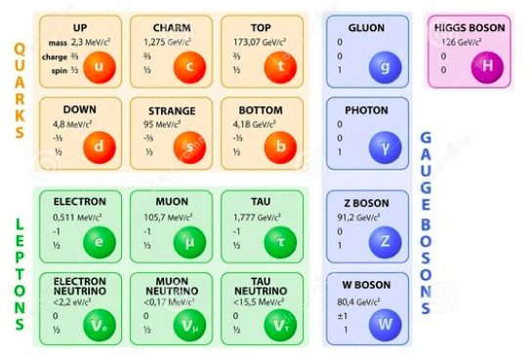

Table of common mesons

|  |  |  |
| --- | --- | --- |
|  |  |  |

|  |
| --- |
|  |
|  |
|  |

**Common Baryons**

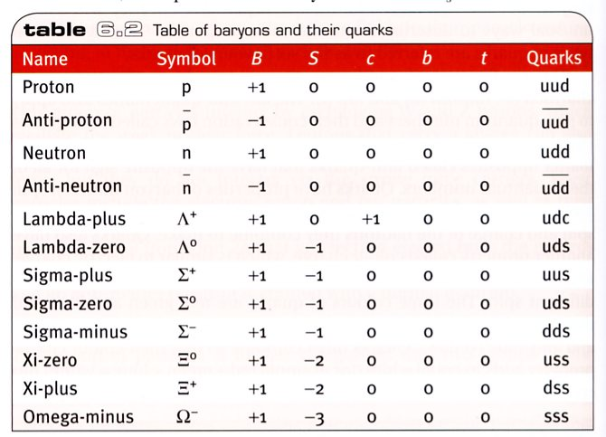

**Common Mesons**

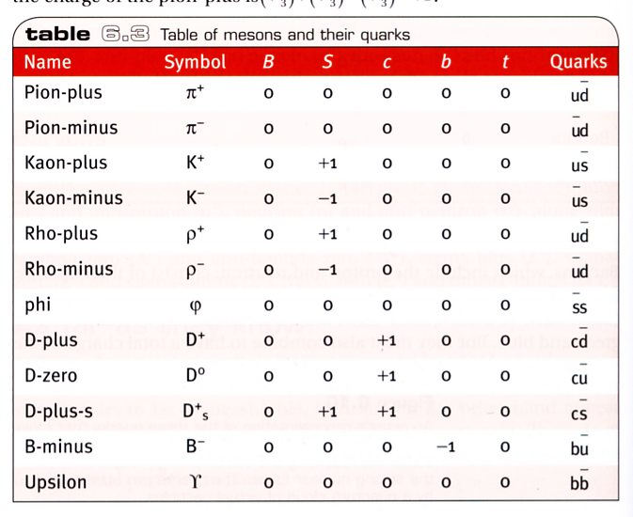

**Redshift and recessional velocity**



It can also be shown that:

where: z = redshift

Δλ = change in wavelength (moving source) (nm)

λ = wavelength of stationary source (nm)

v = recessional speed of galaxy (ms-1)

c0 = speed of light in a vacuum (ms-1)

**Hubble’s Law**



where vgalaxy = recessional speed of galaxy (kms-1)

d = distance to galaxy (Mpc)

Ho = Hubble’s constant (kms-1Mpc-1)

1.00 pc = 3.26 light years

**Circle the correct answer in the following multiple-choice questions.**

1. The reaction μ– → e–  + νe  + νμ conserves: [1 mark]

(a) muon lepton number but not electron lepton number.

(b) electron lepton number but not muon lepton number.

(c) neither muon lepton nor electron lepton number.

(d) both muon and electron lepton numbers.

(e) None of these is correct.

2. A conservation law that is not universal but applies only to certain kinds of interactions is conservation of: [1 mark]

(a) lepton number.

(b) baryon number.

(c) spin.

(d) charge.

(e) strangeness.

3. In quantum electrodynamics (QED), electromagnetic forces are mediated by: [1 mark]

(a) the interaction of electrons.

(b) hadrons.

(c) action at a distance.

(d) the weak nuclear interaction.

(e) the exchange of virtual photons.

4. The cosmic microwave background radiation is [1 mark]

(a) radiation from the quasars that is redshifted.

(b) produced from processes going on all over the present universe.

(c) radiation from the Sun.

(d) radiation from the Big Bang that was around when electrons and protons combined to form neutral hydrogen atoms.

(e) radiation produced from electron-positron annihilation in the intergalactic regions.

5. The conservation law violated by the reaction p → π0 + e+ is the conservation of: [1 mark]

(a) charge.

(b) energy.

(c) linear momentum.

(d) lepton number and baryon number.

(e) angular momentum.

6. An emission line is seen in the spectrum of galaxy A at a wavelength of 459 nm. Analysis of this emission line shows that it has a ***rest*** wavelength in the laboratory of 450 nm.

(a) Calculate the redshift of this galaxy. [2 marks]

(b) Calculate the recessional velocity (in kms-1) of galaxy A. [3 marks]

(c) Given that Hubble’s constant (Ho) has a value of 72.0 kms-1Mpc-1, calculate the distance (in lightyears) to galaxy A. [4 marks]

7. (a) A spacecraft of rest mass 90.0 tonnes is moving away from the Earth at a constant speed.

The crew of the spacecraft determine that it takes them 1.10 years to reach the star Alpha Centauri. Observers on Earth state that it took the spacecraft 4.50 years to complete the journey. Determine the speed of the spacecraft in the reference frame of Earth. [3 marks]

(b) The crew of the spacecraft argue that time recorded on their clocks was correct, but they could reach Alpha Centauri in a time of 1.10 years for a different reason. How is the journey time explained in the reference frame of the spacecraft? Explain with reference to physics principles - no calculation is required. [2 marks]

(c) As the spacecraft goes past Alpha Centauri, it changes its speed to a new constant value of 0.770 *c* in the reference frame of Alpha Centauri. Calculate the relativistic momentum of the spacecraft at this speed. [3 marks]

As the spacecraft is moving away from Alpha Centauri at a speed of 0.770 *c*, it fires a mail canister back towards Alpha Centauri. The canister moves at a speed of 0.580 *c* relative to the spacecraft.

|  |
| --- |
|  |

(d) Determine the speed and direction of the canister in the frame of reference of Alpha Centauri. [3 marks]

(e) As the mail canister moves back towards Alpha Centauri, it directs a laser beam towards the star. What is the speed of the laser beam in the reference frame of Alpha Centauri? Explain briefly. [2 marks]

8. An alien space ship is travelling at 0.650 *c* relative to the Earth. It sends a signal to the Earth’s inhabitants by flashing a light every 0.270 seconds in the ship’s frame of reference. Calculate the time between each flash of light from the Earth’s frame of reference. [3 marks]

9. Figure 3 below represents the decay of a particle X into a particle Y and two other particles. The quark structure of particles X and Y are shown in the diagram.

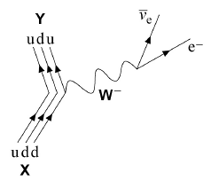

Figure 3

(a) Deduce the name of particle X. [1 mark]

(b) State the type of interaction that occurs in this decay. [1 mark]

(c) State the class of particles to which the W− belongs. [1 mark]

(d) Show clearly how charge and baryon number are conserved in this interaction. You should include reference to all the particles (including the quarks) in your answer. [2 marks]

(e) State the quark constituents of $\overline{Y}$. [1 mark]

(f) Name the only stable baryon. [1 mark]

(g) A muon is an unstable particle. The incomplete decay equation is shown below.

+ ……….

State the name of the missing particle. [1 mark]

10. State what is meant by the term ***luminiferous aether*** and why it was important to classical Physics. [2 marks]

11. Explain why the concept of the aether lost favour in physics and what theory replaced it. [4 marks]

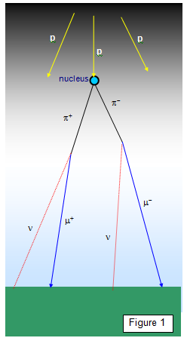12. High-energy cosmic ray protons entering the upper atmosphere interact with the nuclei of oxygen and nitrogen atoms to give a group of particles known as pions. These pions then decay into muons that then move off at a speed of up to 0.994 *c*. These muons are formed at a height of between ten and fifteen thousand metres above the ground.

Explain the significance of muons for Einstein’s Special Theory of Relativity. [3 marks]

13. Explain what is meant by the term ***inertial reference frame***. [2 marks]

End of questions